Nama : Afridho Ikhsan

Kelas : 3A-Informatika

NPM : 2210631170002

Mata Kuliah : Pemrograman Berorientasi Objek (PBO)

1. Buatlah Program seperti berikut ini :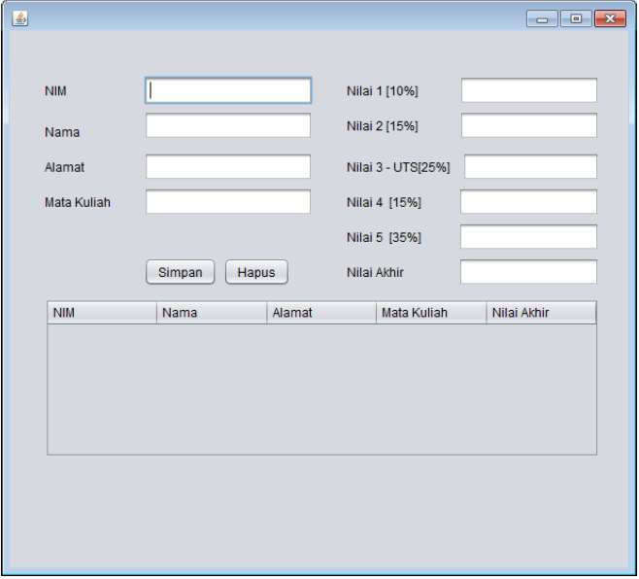

|  |  |
| --- | --- |
| No. | Class DataMahasiswa |
|  | package TugasPertemuan12;  import javax.swing.JOptionPane;  import javax.swing.table.DefaultTableModel;  public class DataMahasiswa extends javax.swing.JFrame {  // Deklarasi Variabel Component  private javax.swing.JButton deletebtn;  private javax.swing.JScrollPane jScrollPane1;  private javax.swing.JTextField kolomAlamat;  private javax.swing.JTextField kolomNama;  private javax.swing.JTextField kolomNim;  private javax.swing.JLabel labelAlamat;  private javax.swing.JTextField labelMataKuliah;  private javax.swing.JLabel labelNama;  private javax.swing.JTextField labelNilai1;  private javax.swing.JTextField labelNilai2;  private javax.swing.JTextField labelNilai3;  private javax.swing.JTextField labelNilai4;  private javax.swing.JTextField labelNilai5;  private javax.swing.JTextField labelNilaiAkhir;  private javax.swing.JLabel labelNim;  private javax.swing.JButton savebtn;  private javax.swing.JTable table;  private javax.swing.table.DefaultTableModel model;  public DataMahasiswa() {  initComponents();  }  private void deletebtnActionPerformed(java.awt.event.ActionEvent evt) {  // TODO add your handling code here:  int confirm = JOptionPane.showConfirmDialog(this, "Apakah anda yakin ingin menghapus data ini?", "Delete Confirmation", JOptionPane.YES_NO_OPTION);  if (confirm == JOptionPane.NO_OPTION) {  return;  }  model = (DefaultTableModel) table.getModel();  int selectedIndex = table.getSelectedRow();  model.removeRow(selectedIndex);  JOptionPane.showMessageDialog(this, "Data mahasiswa berhasil dihapus.");  this.clearInput();  labelNilaiAkhir.setText("");  }  private void savebtnActionPerformed(java.awt.event.ActionEvent evt) {  // TODO add your handling code here:  int confirm = JOptionPane.showConfirmDialog(this, "Apakah data yang ingin anda tambahkan sudah benar?", "Confirm", JOptionPane.YES_NO_OPTION);  if (confirm == JOptionPane.NO_OPTION) {  return;  }  model = (DefaultTableModel) table.getModel();  double nilaiAkhir = Double.parseDouble(labelNilai1.getText()) * 0.1 + Double.parseDouble(labelNilai2.getText()) * 0.15 + Double.parseDouble(labelNilai3.getText()) * 0.25 + Double.parseDouble(labelNilai4.getText()) * 0.15 + Double.parseDouble(labelNilai5.getText()) * 0.35;  model.addRow(new Object[]{  kolomNim.getText(),  kolomNama.getText(),  kolomAlamat.getText(),  labelMataKuliah.getText(),  nilaiAkhir,});  JOptionPane.showMessageDialog(this, "Data mahasiswa berhasil ditambahkan.");  this.clearInput();  labelNilaiAkhir.setText(Double.toString(nilaiAkhir));  }  private void clearInput() {  kolomNim.setText("");  kolomNama.setText("");  kolomAlamat.setText("");  labelMataKuliah.setText("");  labelNilai1.setText("");  labelNilai2.setText("");  labelNilai3.setText("");  labelNilai4.setText("");  labelNilai5.setText("");  }  public static void main(String args[]) {  java.awt.EventQueue.invokeLater(new Runnable() {  public void run() {  new DataMahasiswa().setVisible(true);  }  });  } |

Output Program:

